Task 13 Outputs

Q1. Program to write data to a excel sheet

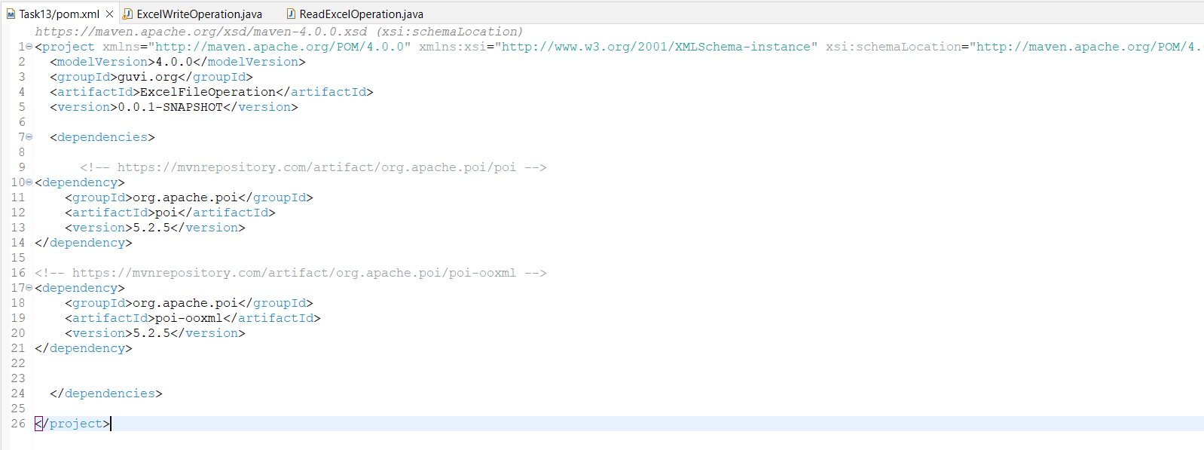

Adding Apache Excel POI Dependencies to the Maven Project

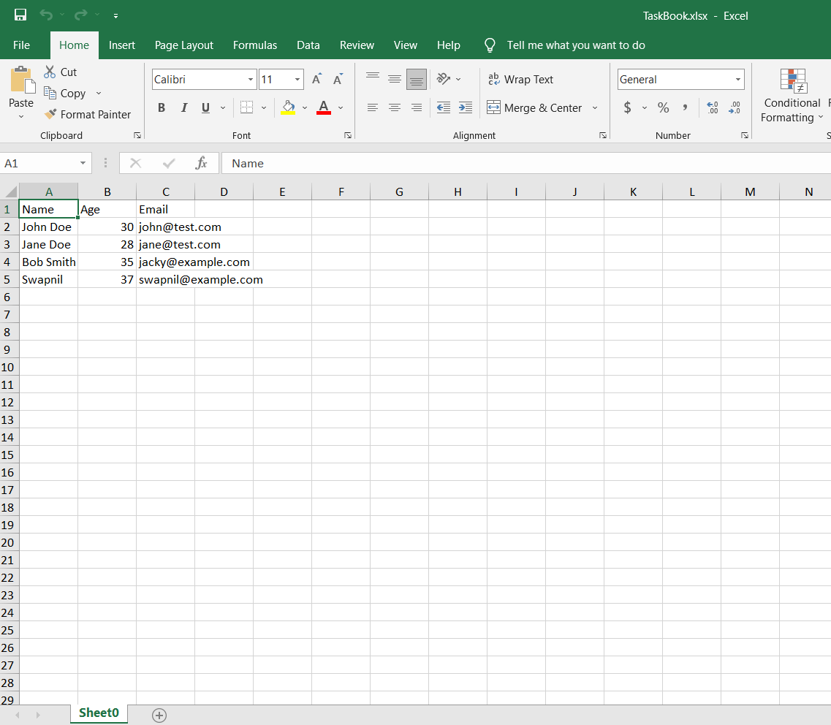

Q1 Output : Creation of Excel book and adding data to the cells through Java

Q2. Program to read data from an existing Excel file

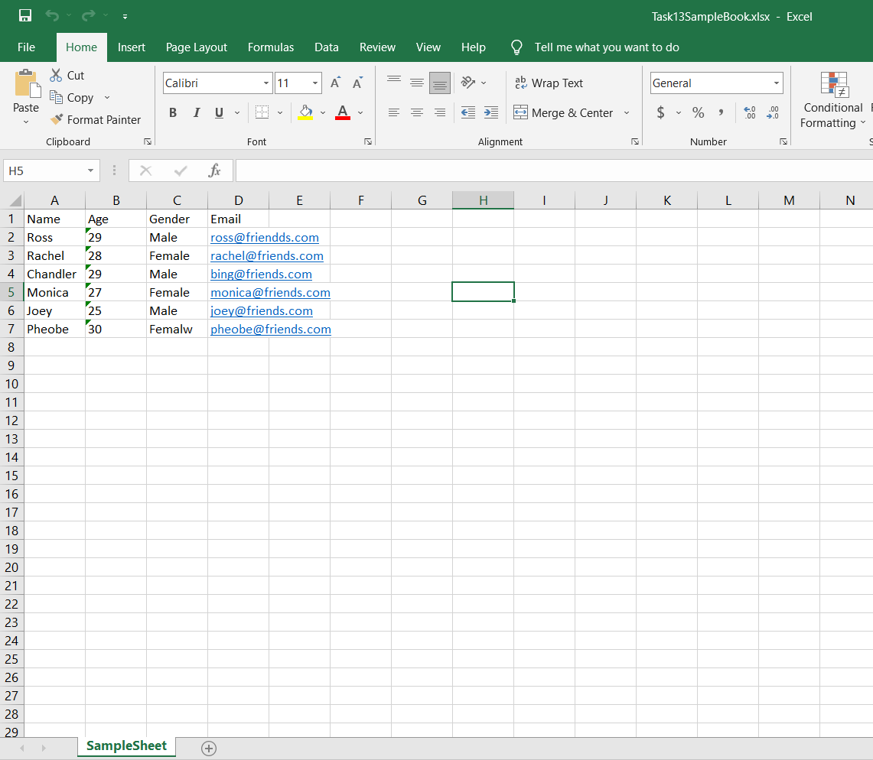

Existing Excel book with some data present

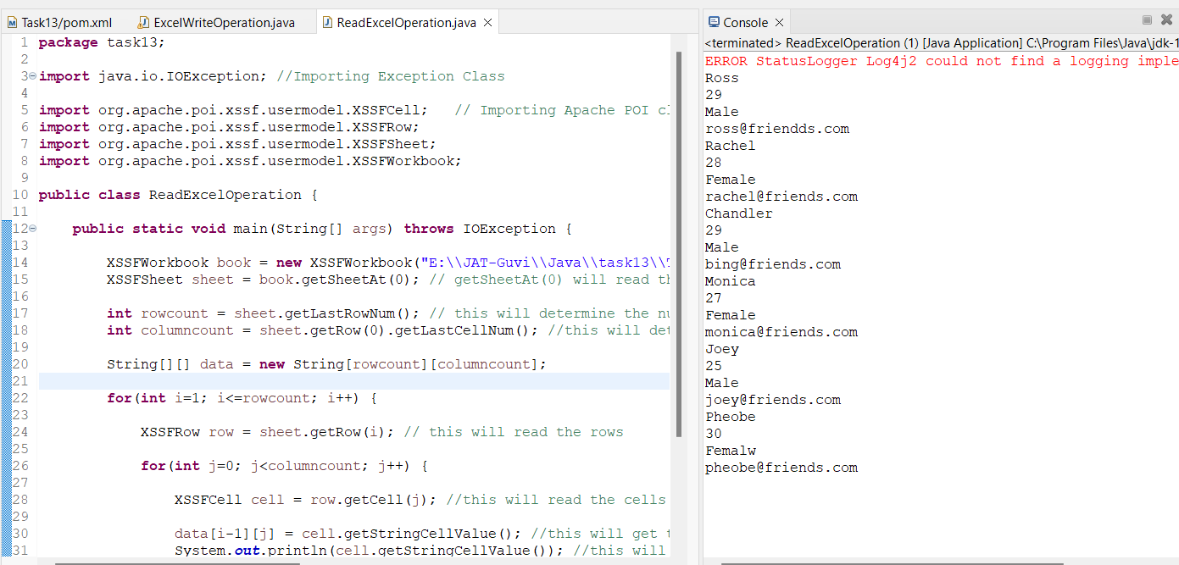

Q2 Output : The data present in the excel file is printed in the console